The City School – Educational Technology Department

Aims+ User Manual

For Campus Guidance

Contents

Introduction 2

Advantages of Aims+ 2

Overview 3

Setup 5

Assign Teacher 5

Assign Student 7

Student Result - Center Wise 8

Student Term Days 8

TCS Reports 9

Non Academic Report 🡪 Non Academic Reports (CO) 9

Academic Report 🡪 Academic Reports (CO) 10

TCS Reports 🡪 Welcome Reports 11

TCS Reports 🡪 A/O Level Reports 12

Results 13

Result Card 13

Search 13

Attendance 14

Attendance 🡪 Calendar 14

Attendance 🡪 Student Attendance 15

Help Desk 16

Help Desk 🡪 Complaint Box 16

Archive Reports 17

Archive 🡪 Archive Reports 17

Manage Resource 18

Mange Resources 🡪 Academic Resources (Down) 18

Mange Resources 🡪 General Resources (Down) 18

Mange Resources 🡪 Drop Box 19

Acknowledgement 21

# Introduction

AIMS+ is an advanced version of idealAims to manage student data. Academic Student Information Systems (Aims+) provide capabilities for entering student test and other assessment scores, build student schedules, track student attendance, and manage many other student-related data needs in a school.

## Advantages of Aims+

* Aims+ Management System turns your manual means of results into digital form over an online hosting platform.
* Archives your school results from the very date you start using it.
* Automatically computes cumulative scores and grades according to figures being keyed in.
* Helps you to call-up a particular student’s result at any point in time.
* Rates your school higher than your competitors.
* Reduces the rate of human errors. E.g. Mis-calculation of cumulative scores.
* Automatically awards remarks to student based on grades.
* Parents and guardians can have access to their ward’s results/performance is school. This helps to put such a student in check.

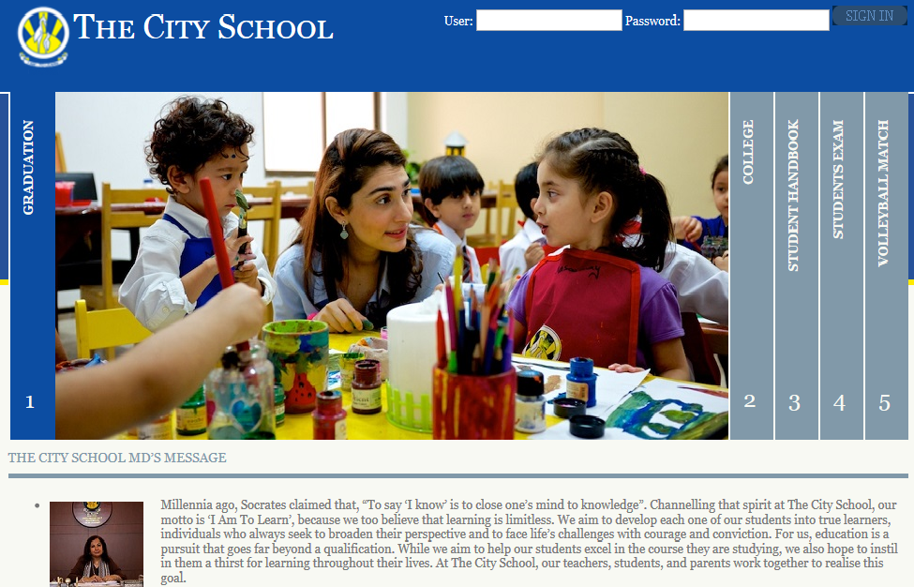

# Overview

1. Setup
2. TCS reports
3. Result
4. Search
5. Attendance
6. Helpdesk
7. Archive
8. Mange Resources

These main menus contain sub menus to facilitate the Campus Officer.

1. Setup

Setup menu contains three sub menus

* Assign Teacher

(Assign teacher to subjects of a class section)

* Assign Student

(Assign student of a class to a section)

* Student Result

(View student’s result)

* Student Term Days

1. TCS reports

There are two types of reports

* Non Academic Report
* Academic Report
* Welcome Reports
* A/O Level Reports

1. Result

* Result Card

(View result card of a student)

1. Search

Campus Officer can search records using following search options

* Search Student
* Search User
* Search Class
* Search Section
* Search Subject

1. Attendance

Campus Officer can enter the attendance of students according to Class Section Wise and have following options

* Calendar
* Student Attendance

1. Helpdesk

Campus officer can use Helpdesk have following option

* Complaint Box

1. Archive

Campus officer can see following archive reports

* Archive Reports

1. Mange Resources

Campus officer has also rights to manage resources

* Academic Resource (Download)
* General Resource (Download)
* Drop Box

# Setup

## Assign Teacher

Setup 🡪 Assign teacher

1. Click on the **Setup** and then click **Assign Teacher**.
2. Here campus officer can assign teachers to subjects of a class section.

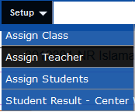

Select class- section from drop down list.

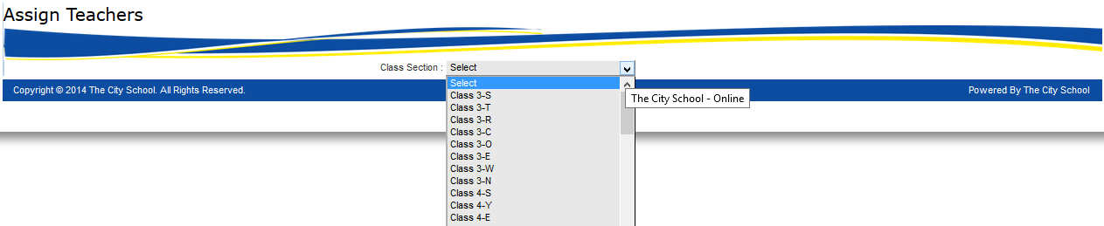

All subjects of selected class-section will appear

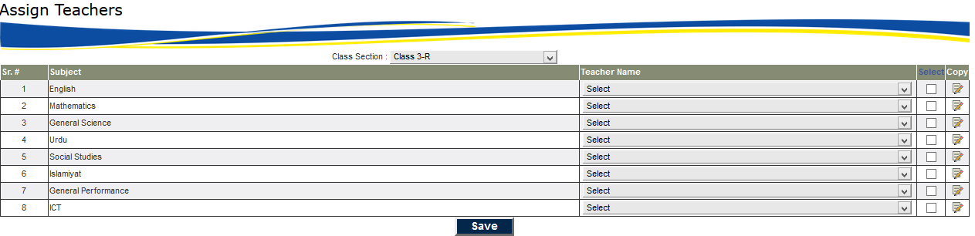

Select teacher from dropdown menu right in front of subject and press save button to save records.

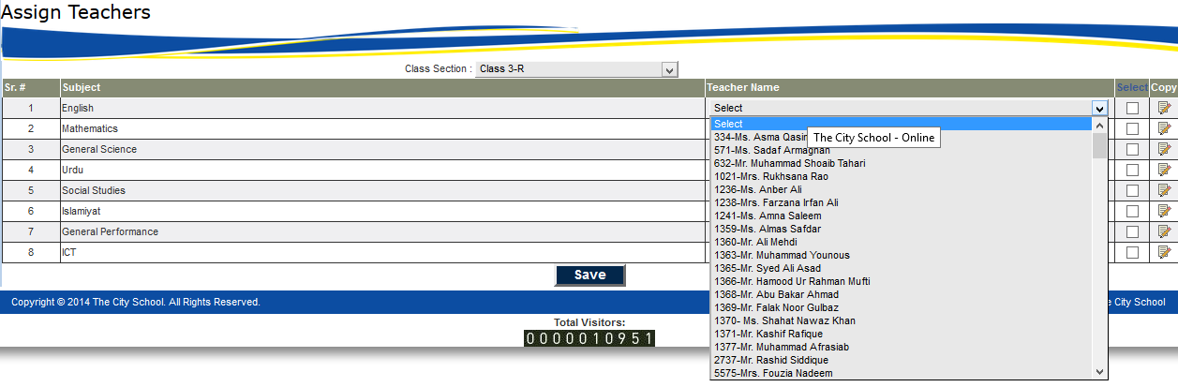

To facilitate user, copy option is available. If the user wants to assign one teacher to all other subjects then select the desired checkboxes and press copy button of any row that is required to paste on all selected rows.

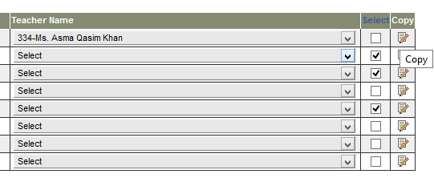

Then selected teacher will assign to selected subjects as shown in below screenshot.

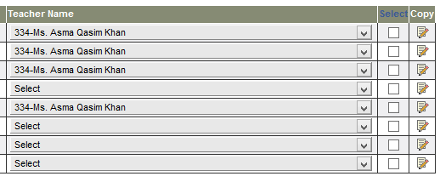

## Assign Student

Setup 🡪 Assign Student

1. Click on the **Setup** and then click **Assign Student**.
2. Here campus officer can assign/un-assign students of a class to section.

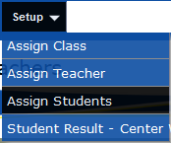

Select Status (Approved/Un assigned and assigned) 🡪 Class available🡪section

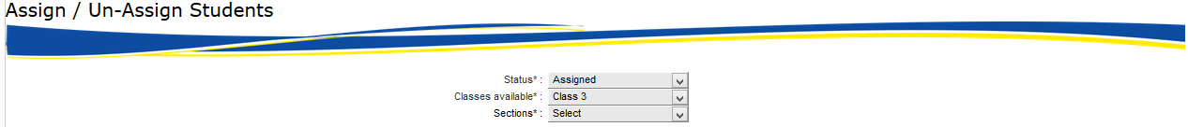

Student’s information will appear in below form

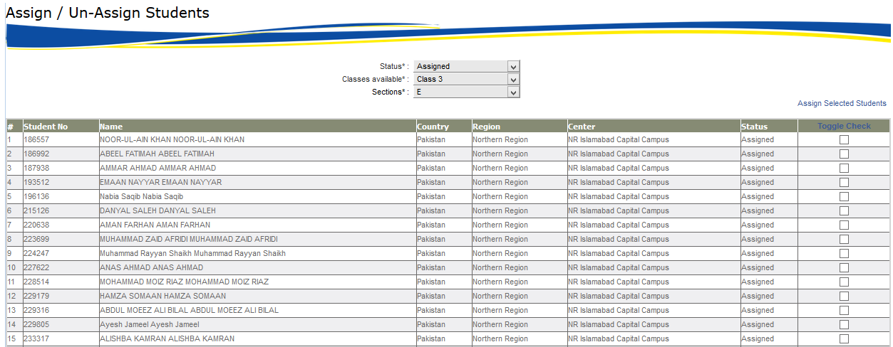

Select checkboxes of desired students and click on **Assign Selected Students** button, a small screen will appear below.

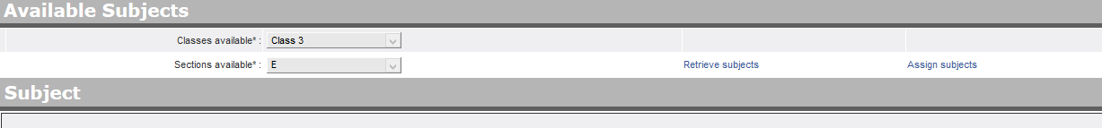

## Student Result - Center Wise

Setup 🡪 Student Result - Center Wise

This screen shows the result of student

Campus officer will select

Class and Section 🡪Term🡪Session and Student

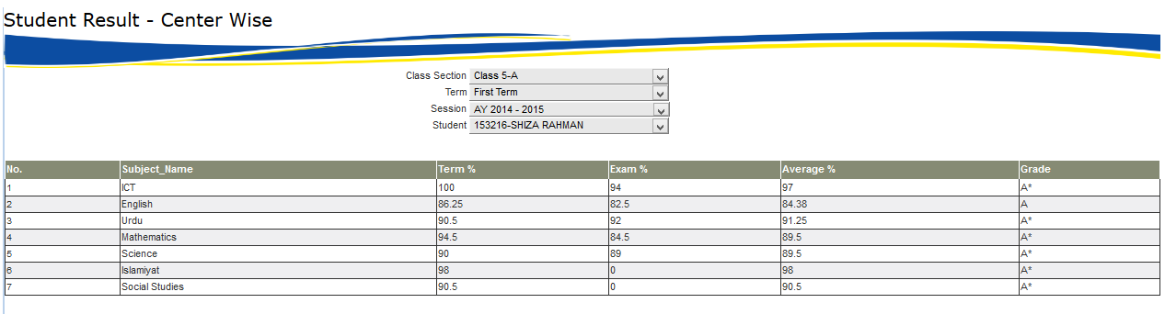

## Student Term Days

Setup 🡪 Student Term Days

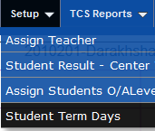

Campus officer can add student term days using this screen by selecting the desired student term wise

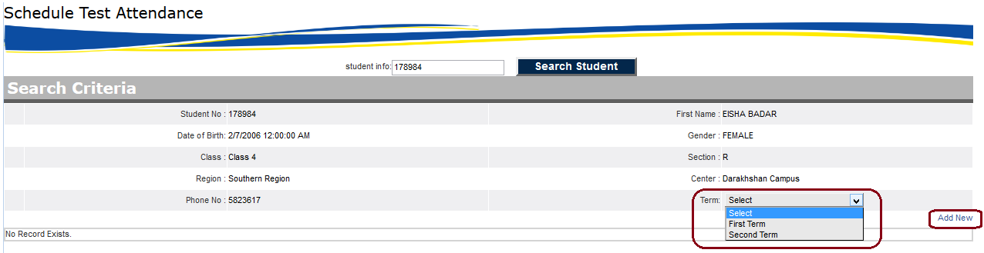

After add the desired student screen will show all which are add in this criteria

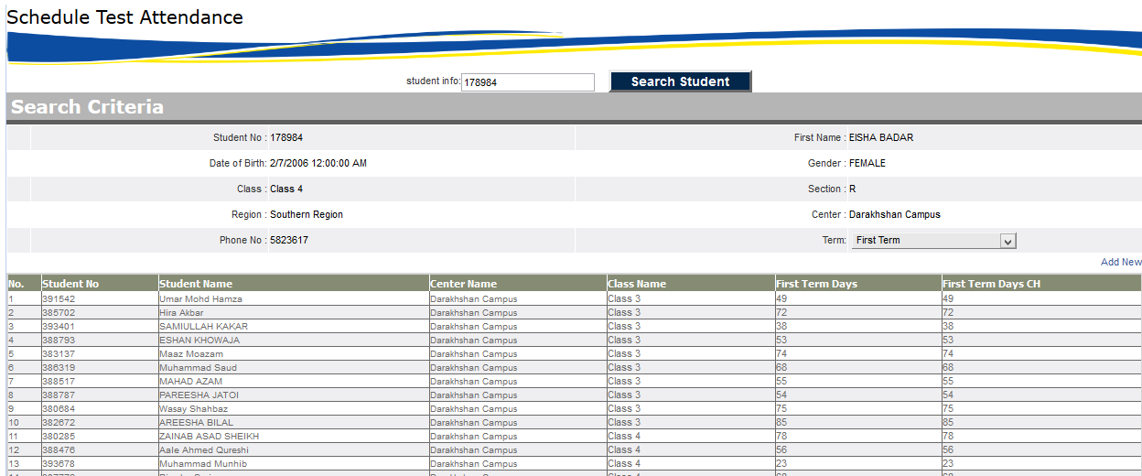

# TCS Reports

## Non Academic Report 🡪 Non Academic Reports (CO)

TCS Reports 🡪 Non Academic Reports 🡪Non Academic Reports (CO)

1. Click on the **TCS Reports 🡪 Non Academic Reports** and then click **Non Academic Reports (CO)**.
2. In this section campus officer can view all non-academic reports.

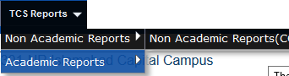

Campus officer will select

Main Organization🡪Main Organization Country🡪Region🡪Center🡪Session🡪Class and Section

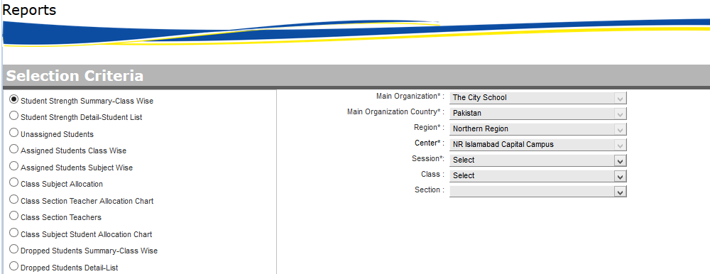

This Screen have following reports

* Student Strength Summary – Class Wise
* Student Strength detail – Student List
* Unassigned Students
* Assigned Students Class Wise
* Assigned Students Subject Wise
* Class Subject Allocation
* Class section Teacher Allocation Chart
* Class Section Teacher
* Class Subject Students Allocation Chart
* Dropped Student Summary – Class Wise
* Dropped Student Detail—list

## Academic Report 🡪 Academic Reports (CO)

(View Academic Reports Center Wise)

TCS Reports 🡪 Academic Reports 🡪 Academic Reports (CO)

1. Click on the **TCS Reports 🡪 Academic Reports** and then click **Academic Reports (CO)**.
2. In this section campus officer can view all academic reports.

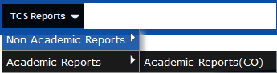

Campus officer will select

Main Organization🡪Main Organization Country🡪Region🡪Center🡪Session🡪Class 🡪 Section and Subject

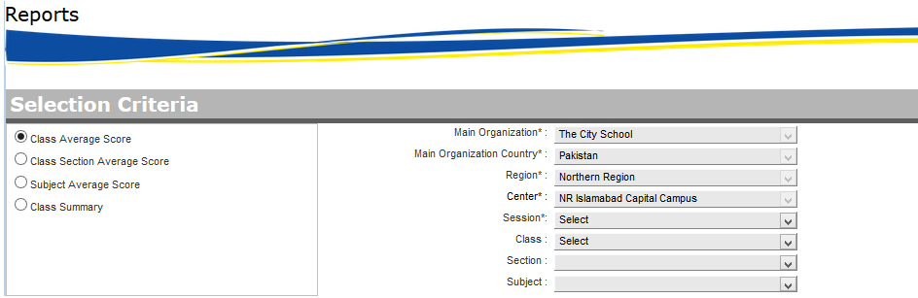

This Screen have following reports

* Class Average Score
* Class section Average Score
* Subject Average Score
* Class Summary

## TCS Reports 🡪 Welcome Reports

TCS Reports 🡪 Welcome Reports

1. Click on the **TCS Reports 🡪 Welcome Reports**
2. In this section campus officer can view all academic reports.

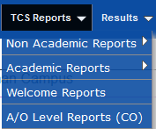

Following reports will show

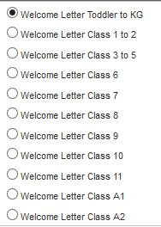

## TCS Reports 🡪 A/O Level Reports

TCS Reports 🡪 A/O Level Reports

1. Click on the **TCS Reports 🡪 A/O Level Reports**
2. In this section campus officer can view all academic reports.



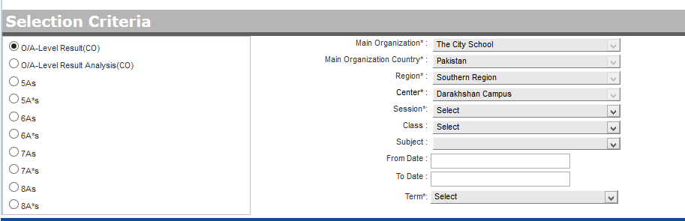

# Results

## Result Card

Results 🡪 Result Card

1. Click on the **Results 🡪 Result Card**
2. In this section campus officer can Results.



Select Main Organization🡪Main Organization Country🡪Region🡪Center🡪Session🡪Class 🡪 Section 🡪 Subject and Term

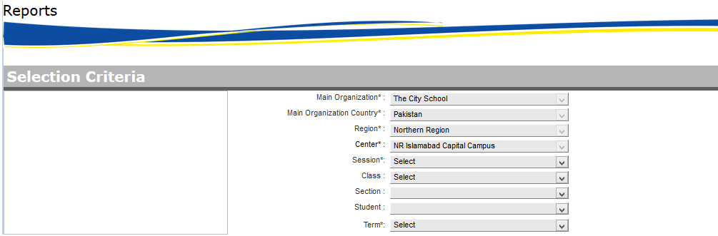

# Search

This system provide facility to search criteria for users and have following categories

**Search** 🡪 **Search Student**

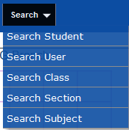

* Search Student
* Search User
* Search Class
* Search Section
* Search Subjects

Campus officer can search his desired information by given screen. These screens contains some filters like

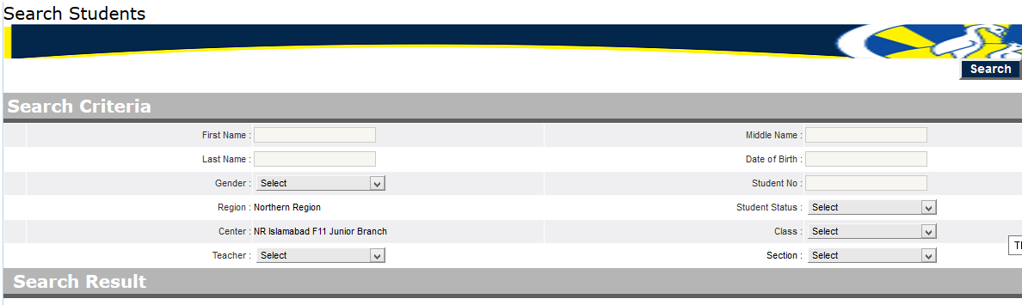

And desired result shown in grid form

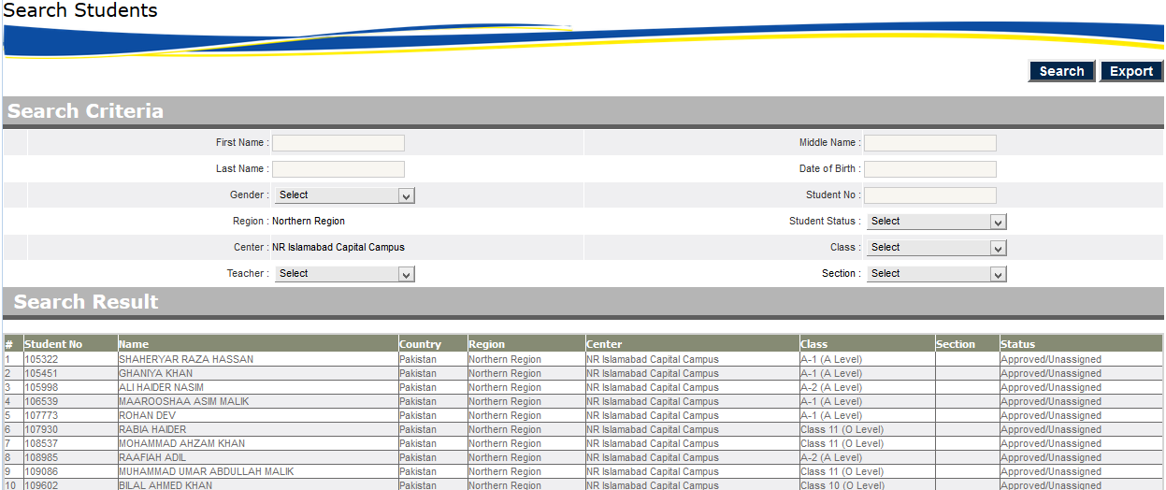

# Attendance

This system provide facility to input student Attendance on class section wise and have following option

## Attendance 🡪 Calendar

Attendance 🡪 Calendar

1. Click on the **Attendance 🡪 calendar**
2. In this section campus officer can all kind of holidays

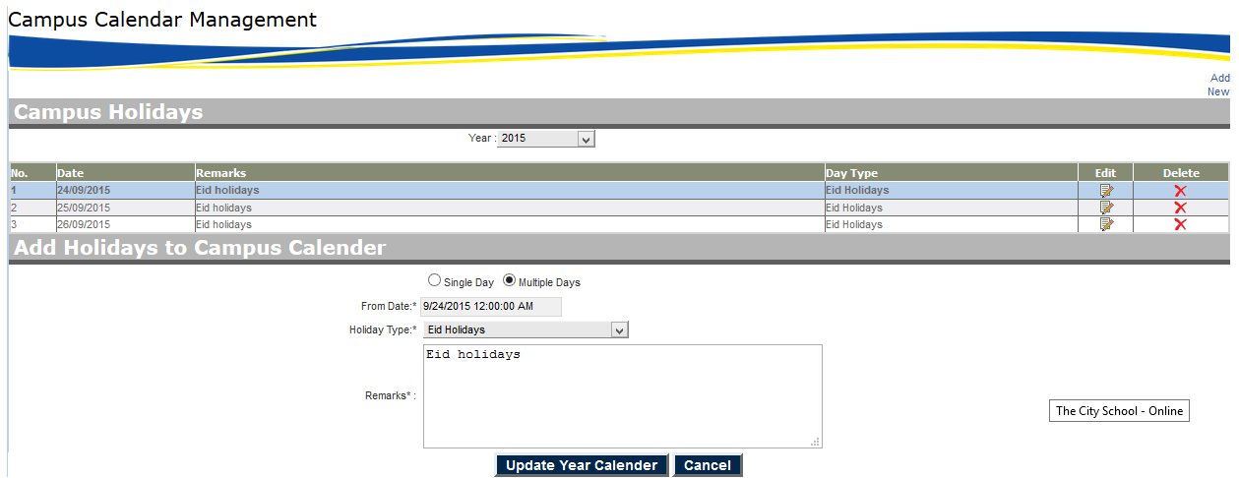

## Attendance 🡪 Student Attendance

Attendance 🡪 Student Attendance

1. Click on the **Attendance 🡪 Student Attendance**
2. In this section campus officer can submit student attendance on class section wise

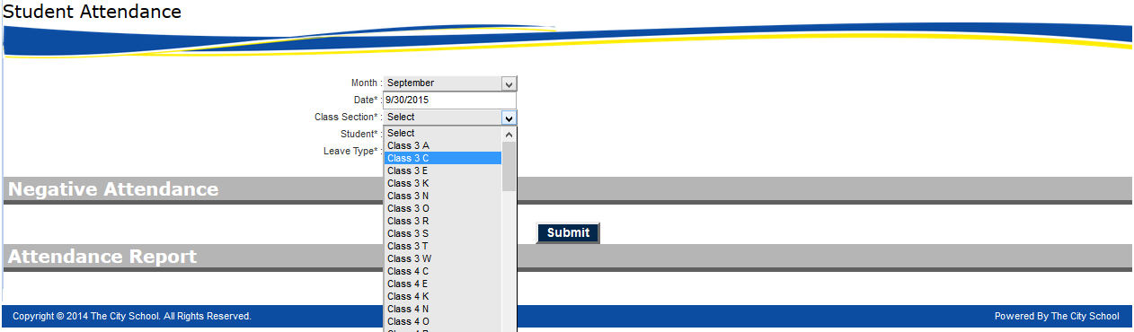

Campus officer can submit absent and other kind of leaves of relevant student

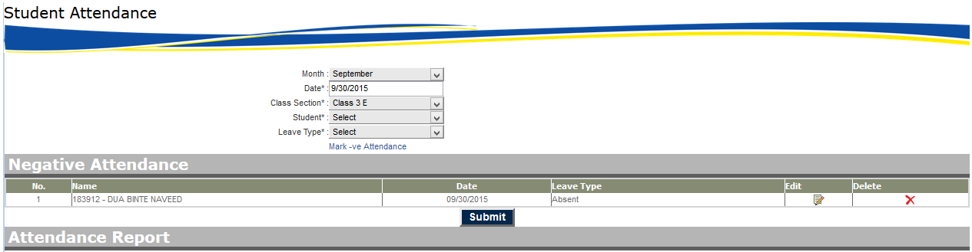

Then after submit system automatically generate the whole attendance of all students.

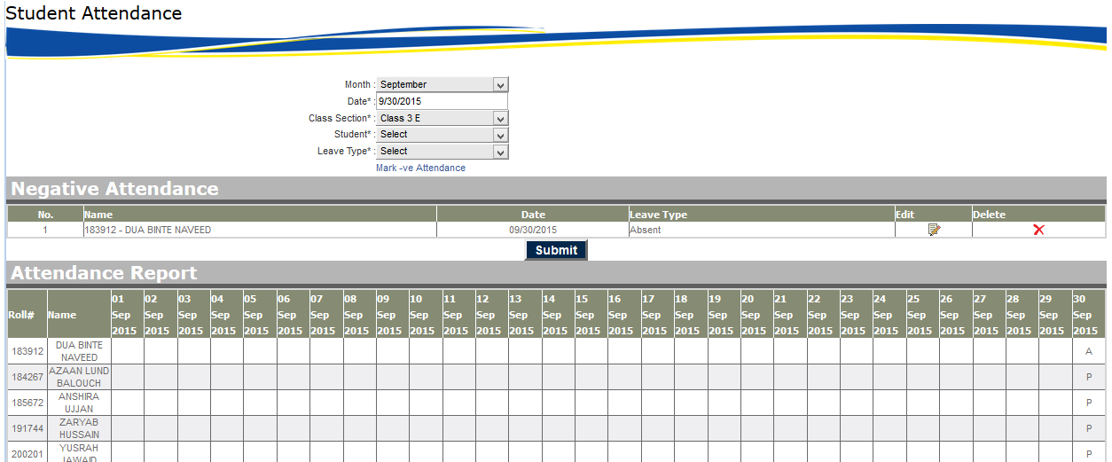

# Help Desk

## Help Desk 🡪 Complaint Box

Help Desk 🡪 Complaint Box

1. Click on the **Help Desk 🡪 Complaint Box**
2. In this section campus officer can use complaint box

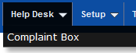

Campus officer can check the status of requests of relevant center only.

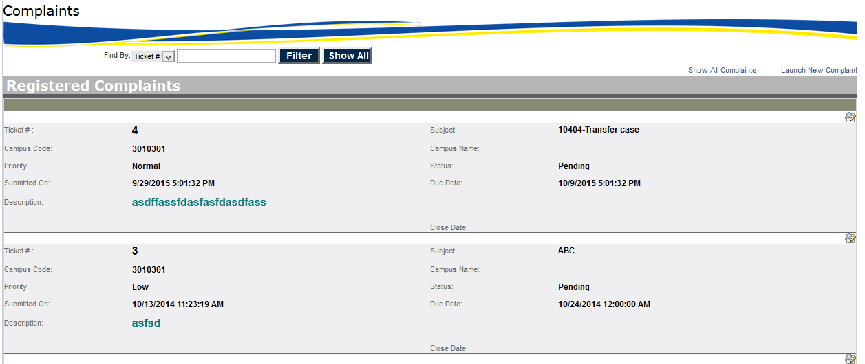

# Archive Reports

## Archive 🡪 Archive Reports

Archive🡪 Archive Reports

1. Click on the **Archive 🡪 Archive Reports**

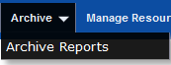

Campus officer will select

Main Organization🡪Main Organization Country🡪Region🡪Center🡪Session🡪Term

And have following reports

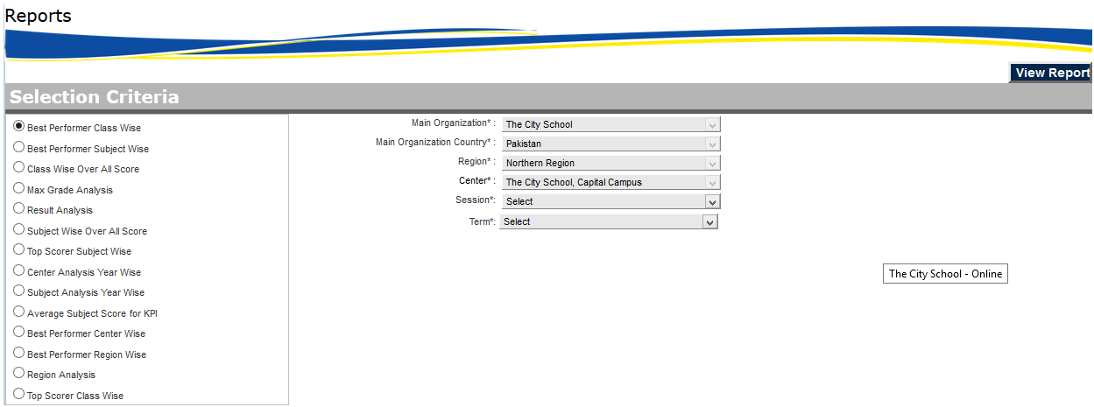

# Manage Resource

This system provide facility to manage electronic material and resources and have following option

## Mange Resources 🡪 Academic Resources (Down)

Manage Resources 🡪 Academic Resources (Down)

1. Click on the **Manage Resources 🡪 Academic Resources (Down)**

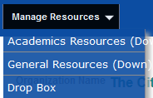

In this section campus officer can download class section wise material

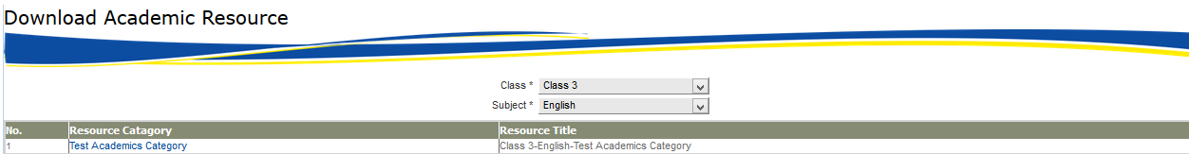

Then after click on desired resource category system will show the share folder where the relevant material has been uploaded

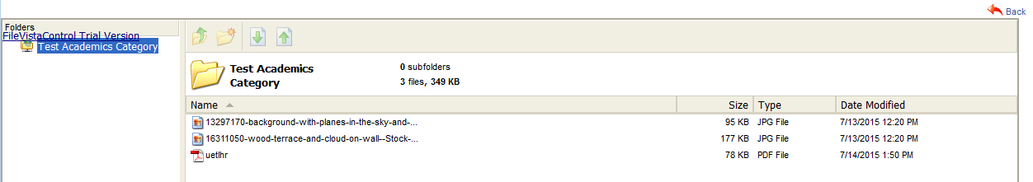

Then campus officer can download the relevant material

## Mange Resources 🡪 General Resources (Down)

Manage Resources 🡪 General Resources (Down)

1. Click on the **Manage Resources 🡪 General Resources (Down)**



In this section campus officer can download general resources material



Then after click on common resource campus officer can download relevant material like this

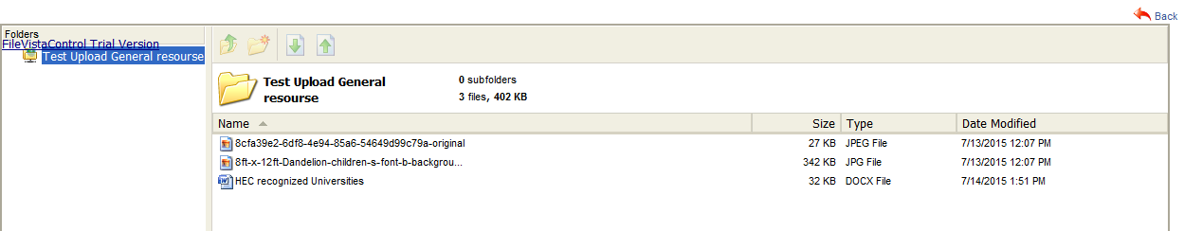

## Mange Resources 🡪 Drop Box

Manage Resources 🡪 Drop Box

1. Click on the **Manage Resources 🡪 Drop Box**



In this section campus officer has facility to download and upload material

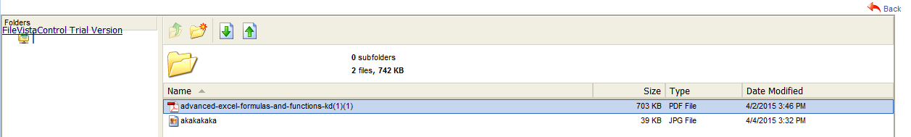

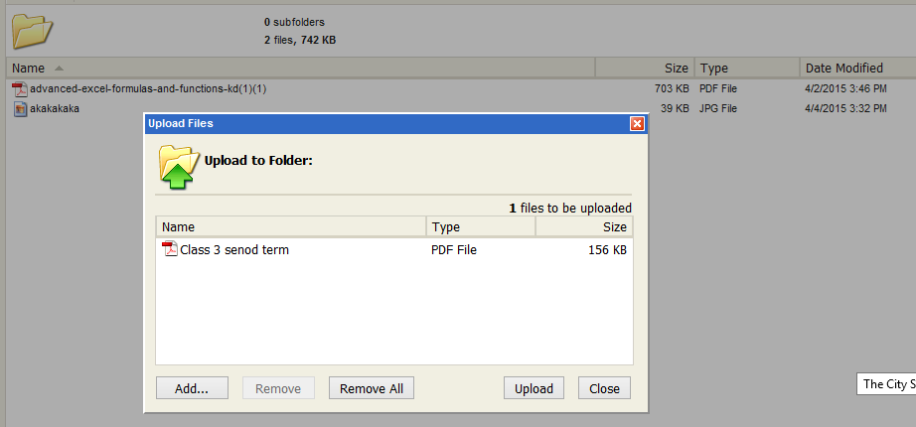

Then after uploading

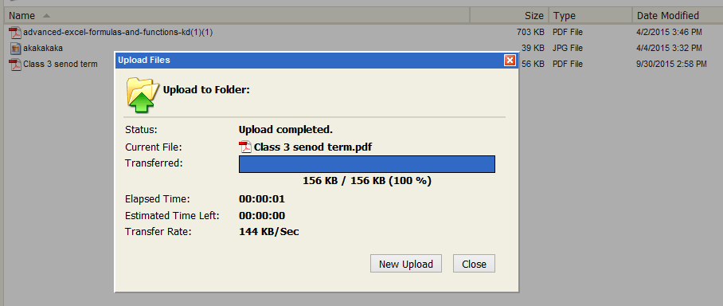

Campus officer have multiple choices option to upload and download files.

# Acknowledgement

This system provide facility to acknowledgement of students

Acknowledgement 🡪 Letter of undertaking acknowledgement

1. Click on the **Acknowledgement** **🡪 Letter Of Undertaking Acknowledgement**



Campus officer can select term wise students and generate the letter of undertaking with toggle check functionality

